Outer Ring Road, Near Marathalli, Bellandur Main Road, Bengaluru, Karnataka - 560 103

Academic Year : 2021 – 2022 (Even Semester)

Year / Sem : 2022/II

Sec : I

Name and Roll No : 1) Dhanush V - 1NH21CE014 (I59)

2) Mohith S - 1NH21CE036 (I46)

3) Chayana P - 1NH21CE047 (I45)

Course Name : Problem solving using python

Course Code : 21CSE23A

Mini Project Report Submitted to : Professor Nirmala

Project Title : GAME OF LUCK

Submitted on : 19-8-2022



**CERTIFICATE**

This is to certify that the mini project work titled

**GAME OF LUCK**

Submitted by:

Dhanush V - 1NH21CE014 (I59)

Mohith S - 1NH21CE036 (I46)

Chayana P - 1NH21CE047 (I45)

*DURING*

*EVEN SEMESTER 2021-2022*

*for*

*Course: Mini Project in Python-21CSE13*

Signature of Reviewer Signature of HOD

**SEMESTER END EXAMINATION**

*Name of the Examiner Signature with date*

**Abstract**

Digital gaming has emerged as one of the most engaging forms of entertainment for all generations. People across various age groups have taken to various forms of available online games based on their preferences and interests. Over the years, digital gaming has become a double-edged sword in light of its addictive nature. However, its drawbacks, digital gaming has proved to be beneficial in various facets of our lives. Upon choosing the right game, one can challenge and hone their mental prowess by enriching their thinking capabilities and fostering lateral and analytical thinking. Games such as quizzes, puzzles, card games like Poker, war games, etc. encourage people to strategize, analyse and find solutions by encouraging tactical-thinking.

Many digital games require strong retention ability both; visual and auditory. These games have proved to be beneficial in real life as one can utilize these enhanced skills in their everyday activities. Online games aid in strengthening our long term and short-term memory as well. When we challenge our brain, it works more efficiently and adapts a quick-thinking approach in solving daily problems

**ACKNOWLEDGMENT**

An explosion happens because of the ignition of a spark. In a similar way this project would not have happened if it wasn’t for the people who made it possible. So, I would like to thank these hard working people.

I am going to start by thanking **Dr. Mohan Manghnani**, Chairman, New Horizon College of Engineering, for providing the amazing infrastructure of the college.

Next I would like to thank to **Dr. Manjunatha**, Principal, New Horizon College of Engineering, for his support.

I would like to thank **Dr. R.J. Anandhi**, Professor and Dean-Academics, NHCE, for his valuable guidance.

I would also like to thank **Dr. Anusuya Devi**, Professor and HOD, Department of Applied Science for her support.

Finally I express my gratitude to **Dr. Nirmala M**, Associate Professor, Department of Computer Science and Engineering, my mini project reviewer, for constantly monitoring the development of the project and helping me solve my problems. Her valuable suggestions werevery useful to me for developing and further improving my mini project.

**INDEX**

|  |  |  |
| --- | --- | --- |
| S.No. | Topic | Page Number |
| 1 | Introduction | 6 |
| 2 | Methods and loops used | 7 |
| 3 | Algorithum | 9 |
| 4 | The Program | 11 |
| 5 | The Output | 12 |
| 6 | Conclusion | 13 |

**1. INTRODUCTION**

**1.1 ABOUT PYTHON:**

Python is a widely-used general-purpose, high-level programming language. It was initially designed by Guido van Rossum in 1991 and developed by Python Software Foundation. It was mainly developed for emphasis on code readability, and its syntax allows programmers to express concepts in fewer lines of code.

In the late 1980s, history was about to be written. It was that time when working on Python started. Soon after that, Guido Van Rossum began doing its application-based work in December of 1989 at Centrum Wiskunde & Informatica (CWI) which is situated in the **Netherlands**. It was started firstly as a hobby project because he was looking for an interesting project to keep him occupied during Christmas.

The language was finally released in 1991. When it was released, it used a lot fewer codes to express the concepts, when we compare it with Java, C++ & C. Its design philosophy was quite good too.

**1.2 What was python built for :**

Its main objective is to provide code readability and advanced developer productivity. When it was released it had more than enough capability to provide classes with inheritance, several core data types exception handling and functions. Python is commonly used for **developing websites and software, task automation, data analysis, and data visualization**. Since it's relatively easy to learn, Python has been adopted by many non-programmers such as accountants and scientists, for a variety of everyday tasks, like organizing finances.in a much more technical world python is used **in AI and machine learning, data analytics, web development, block chain, search engine optimization(SEO), automation and game development.**

Python is not a widely used programming language for game development, but yet it is very popular in creating simpler games. The speed at which games can be created in Python, owing to its simplicity, mean that it is also a fabulous option for building prototypes and developing ideas in the gaming industry, allowing more flexibility and faster processes than other alternatives.

**2. Methods and loops used:**

The rock, paper and scissors game requires a very a basic level of programming knowledge. We have created this game using only two loops, which are for and if-elif loop.

2.1 For loop:

**for in Loop:** For loops are used for sequential traversal. For example: traversing a list or string or array etc. In Python, there is no C style for loop, i.e., for (i=0; i<n; i++). There is “for in” loop which is similar to each loop in other languages.

**Syntax:**

for iterator_var in sequence:

statements(s)

It can be used to iterate over a range and iterators.

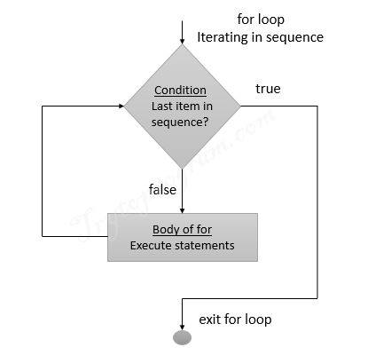

**Example**:

# Python program to illustrate

# Iteration over range 0 to n-1

n = 4

for i in range(0, n):

print(i)

**output**:

0

1

2

3

**2.2 If-elif loop:**

In Python, the body of the if statement is indicated by the indentation. The body starts with an indentation and the first unindented line marks the end. The if-elif-else statement is used in Python for decision making. The **elif** statement allows you to check multiple expressions for TRUE and execute a block of code as soon as one of the conditions evaluates to TRUE. Similar to the **else**, the **elif** statement is optional. However, unlike **else**, for which there can be at most one statement, there can be an arbitrary number of **elif** statements following an **if**.

**Syntax**:

if test expression:

Body of if

elif test expression:

Body of elif

else:

Body of else

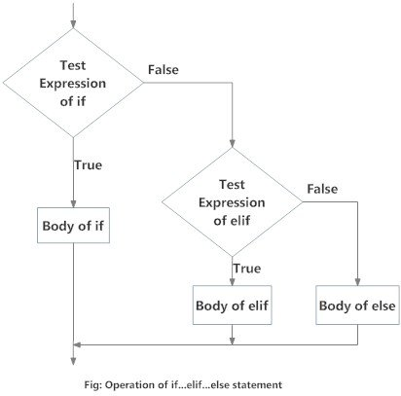

**Example**:

num = 3.4

if num > 0:

print("Positive number")

elif num == 0:

print("Zero")

else:

print("Negative number")

**output**:

Positive number

**3. ALGORITHUM:**

STEP 1: Start

STEP 2:Input n

STEP 3:Input player_choice

STEP 4: if (computer_choice =rock and player_choice =paper)

Print "player wins"

Else if(computer_choice =rock and player_choice =scissors )

Print "computer wins"

Else if(computer_choice =rock and player_choice =rock)

Print "its a tie"

Else if(computer_choice =paper and player_choice =rock)

Print "the computer wins"

Else if(computer_choice =paper and player_choice =scissors)

Print "the player win"

Else if(computer_choice =paper and player_choice =paper)

Print "its a tie"

Else if(computer_choice =scissors and player_choice =rock)

Print "player wins"

Else if(computer_choice =scissors and player_choice =paper)

Print "computer wins"

Else if(computer_choice =scissors and player_choice =scissors)

Print "its a tie"

Else

Print "invalid input"

STEP 5: Stop

**4. THE PROGRAME:**

import random

n=int(input("How many times do you want to play: "))

for i in range (n):

player_choice=input("what do you chose? rock, paper or scissors.\n")

computer_options=["rock","paper","scissors"]

computer_choice=random.choice(computer_options)

print("computer choice is ",computer_choice)

if(computer_choice=="rock" and player_choice=="paper"):

print("player wins ")

elif(computer_choice=="rock" and player_choice=="scissors"):

print("computer wins")

elif(computer_choice=="rock" and player_choice=="rock"):

print("its a tie")

elif(computer_choice=="paper"and player_choice=="rock"):

print("the computer wins")

elif(computer_choice=="paper" and player_choice=="scissors"):

print("the player win")

elif(computer_choice=="paper" and player_choice=="paper"):

print("its a tie")

elif(computer_choice=="scissors" and player_choice=="rock"):

print("player wins")

elif(computer_choice=="scissors" and player_choice=="paper"):

print("computer wins")

elif(computer_choice=="scissors" and player_choice=="scissors"):

print("its a tie")

else:

print("invalid input")

**5. Output:**

How many times do you want to play: 3

what do you chose? rock, paper or scissors.

rock

computer choice is rock

its a tie

what do you chose? rock, paper or scissors.

paper

computer choice is paper

its a tie

what do you chose? rock, paper or scissors.

rock

computer choice is paper

the computer wins

**6.conclusion:**

The program is succsefully able to produce outputs as per the instructions. The computers choice between rock, paper and scissors was completely random so there was no way of winning against the computer every time. This project aims at making the very basic game of rock, paper and scissors using simple code. The entire code was built using python programming language and uses simple loops and methods which is easy to understand and use. The programme has been made usind visual studio code as IDE. The user can easily understand how to use the program and the program itself has a lot of instructions that the used can easily follow to attain desired results.